1-Glyph

What is Glyph
# Source: Chatgpt (GPT-4-turbo) at [7/21/2025]
A glyph is a specific visual form or design of a written character. It is how a grapheme (or part of one) actually appears on the page or screen, including its style, shape, or variation.

🧾 Definition:
# Source: Chatgpt (GPT-4-turbo) at [7/21/2025]
A glyph is a concrete visual representation of a character (or grapheme), especially in a particular font, style, or context.

🔤 Glyph vs. Grapheme:
# Source: Chatgpt (GPT-4-turbo) at [7/21/2025]
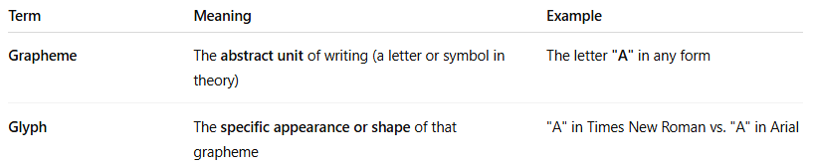

Term | Meaning | Example
Grapheme | The abstract unit of writing (a letter or symbol in theory) | The letter "A" in any form
Glyph | The specific appearance or shape of that grapheme | "A" in Times New Roman vs. "A" in Arial

🖍️ Examples of Glyphs:
# Source: Chatgpt (GPT-4-turbo) at [7/21/2025]
- Font Variations:
  - The letter "g" may appear differently in different fonts:
    - Single-story g: g
    - Double-story g: 𝓰
Both represent the same grapheme but are different glyphs.
- Diacritic Forms:
  - The grapheme "e" can have multiple glyphs:
    - e, é, è, ê — same base letter, different glyphs depending on diacritics.
- Ligatures:
  - A ligature like "æ" (a+e joined) is a glyph representing two letters as one shape.
- Chinese or Arabic Characters:
  - One character (grapheme) might have multiple stylistic or calligraphic glyphs, especially in traditional vs. simplified forms.

Glyph Photo
# Source: Wiki source: Glyph -> at - (Top)
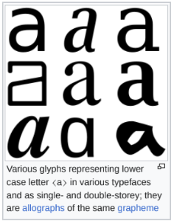

🎨 In Typography:
# Source: Chatgpt (GPT-4-turbo) at [7/21/2025]
Glyphs are used by fonts to display characters. A single font might contain hundreds or thousands of glyphs to account for all stylistic and language variations.

📝 Summary:
# Source: Chatgpt (GPT-4-turbo) at [7/21/2025]
A glyph is the visual shape or design of a written character, while a grapheme is the abstract idea of that character. You can think of a grapheme as the "letter" and the glyph as its "drawing."

2-Allograph

✍️ What is an Allograph?
# Source: Chatgpt (GPT-4-turbo) at [7/21/2025]
An allograph is a variant form of a grapheme — in other words, it's a different way of writing the same letter or character, without changing its meaning or sound.

🧾 Definition:
# Source: Chatgpt (GPT-4-turbo) at [7/21/2025]
An allograph is one of several possible written forms of the same grapheme.

🔤 Key Idea:
# Source: Chatgpt (GPT-4-turbo) at [7/21/2025]
- Grapheme = the abstract unit of writing (e.g., the letter "A")
- Allograph = the different visual versions of that grapheme

🖍️ Examples of Allographs in English:
# Source: Chatgpt (GPT-4-turbo) at [7/21/2025]
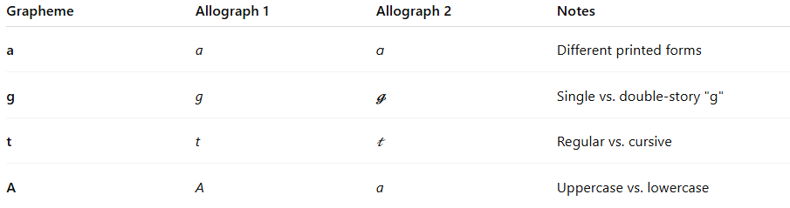
Grapheme | Allograph 1 | Allograph 2 | Notes
a | a | ɑ | Different printed forms
g | g | 𝓰 | Single vs. double-story "g"
t | t | 𝓉 | Regular vs. cursive
A | A | a | Uppercase vs. lowercase

Allograph Photo
# Source: Wiki source: Allograph -> at - (Top)
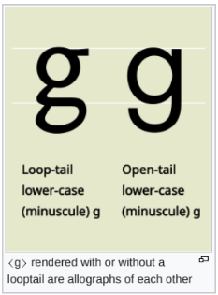

✍️ Handwriting vs Print:
# Source: Chatgpt (GPT-4-turbo) at [7/21/2025]
- Printed "g": g (double-story)
- Handwritten "g": g (single-story)
→ These are allographs of the same grapheme "g".

🌐 In Other Languages:
# Source: Chatgpt (GPT-4-turbo) at [7/21/2025]
- In Arabic, a single letter has different allographs depending on its position:
  - Beginning, middle, end, or isolated
  - Example: The letter ʿAyn (ع) looks different in each position but represents the same sound.

📝 Allograph vs. Glyph vs. Grapheme
# Source: Chatgpt (GPT-4-turbo) at [7/21/2025]
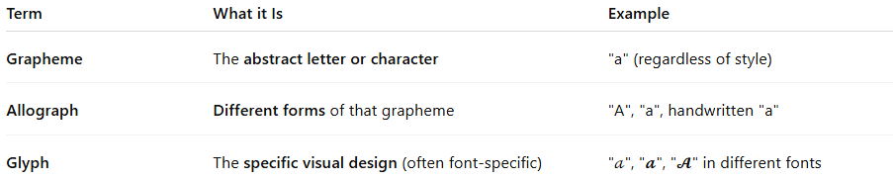
Term | What it Is | Example
Grapheme | The abstract letter or character | "a" (regardless of style)
Allograph | Different forms of that grapheme | "A", "a", handwritten "a"
Glyph | The specific visual design (often font-specific) | "𝒶", "𝓪", "𝓐" in different fonts

Allograph vs. Glyph
# Source: Chatgpt (GPT-4-turbo) at [7/21/2025
Great question! The terms allograph and glyph are closely related, but they are not exactly the same. Here's a clear explanation of their differences:

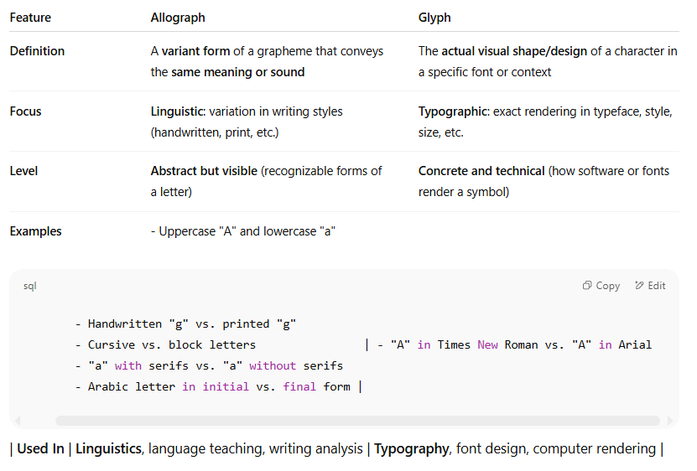
Feature | Allograph | Glyph
Definition | A variant form of a grapheme that conveys the same meaning or sound | The actual visual shape/design of a character in a specific font or context
Focus | Linguistic: variation in writing styles (handwritten, print, etc.) | Typographic: exact rendering in typeface, style, size, etc.
Level | Abstract but visible (recognizable forms of a letter) | Concrete and technical (how software or fonts render a symbol)
Examples | - Uppercase "A" and lowercase "a"
- Handwritten "g" vs. printed "g"
- Cursive vs. block letters | - "A" in Times New Roman vs. "A" in Arial
- "a" with serifs vs. "a" without serifs
- Arabic letter in initial vs. final form |

| Used In | Linguistics, language teaching, writing analysis | Typography, font design, computer rendering |

✅ Simple Analogy:
# Source: Chatgpt (GPT-4-turbo) at [7/21/2025]
- 🔠 Allograph = Different styles of writing the same letter (like cursive "a" vs. printed "a")
- 🎨 Glyph = The exact picture or shape of that letter in a specific font and style

🔤 Example Using the Letter "g":
# Source: Chatgpt (GPT-4-turbo) at [7/21/2025]
- Allographs of "g":
  - Printed double-story g: g
  - Handwritten single-story g: 𝓰
  - Both are allographs of the grapheme "g"
- Glyphs of "g" in different fonts:
  - g in Times New Roman
  - g in Arial
  - g in Comic Sans
  - All are different glyphs (visual shapes) of the same allograph

📝 Summary:
# Source: Chatgpt (GPT-4-turbo) at [7/21/2025]
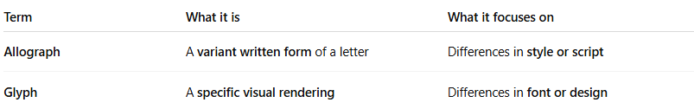

Term | What it is | What it focuses on
Allograph | A variant written form of a letter | Differences in style or script
Glyph | A specific visual rendering | Differences in font or design

✅ Summary:
# Source: Chatgpt (GPT-4-turbo) at [7/21/2025]
An allograph is a variant written form of a grapheme that doesn't change its meaning or pronunciation. It's how one letter can look different in handwriting, print, or different fonts — but still be understood as the same letter.

